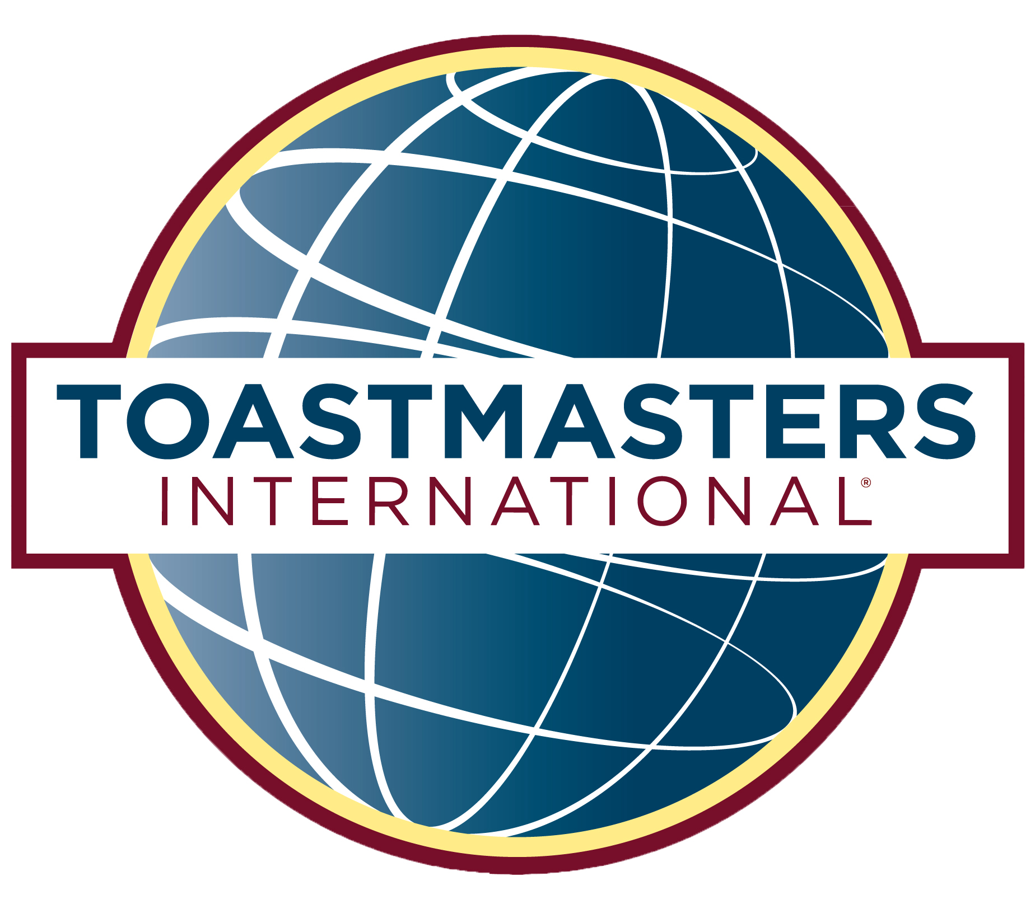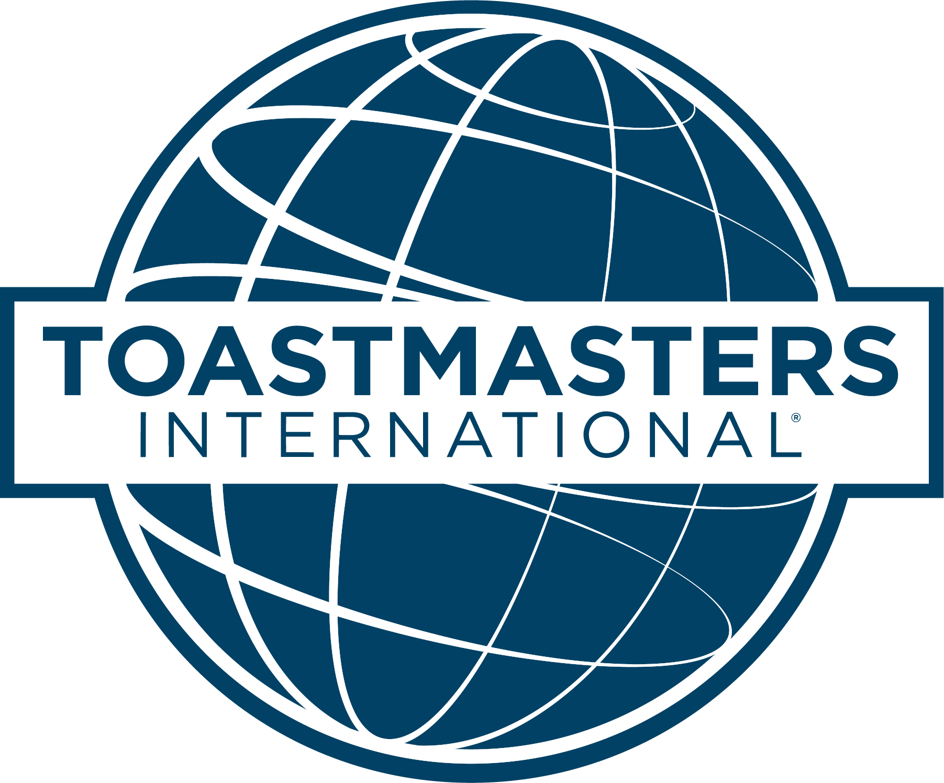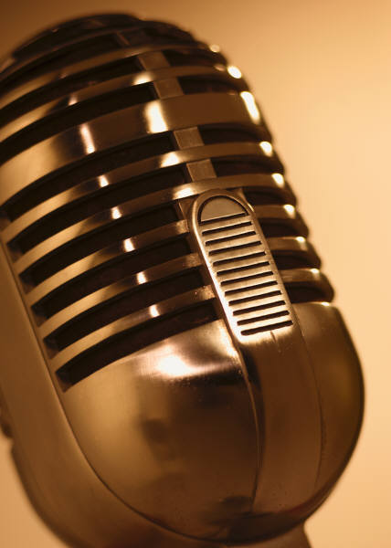

**Thank you for attending the Area 7 Humorous Speech and Table Topics Contest. As your Area Director, I am excited to work with every club in our Area and strive to help all 6 clubs reach their fullest potential. My goal is to help all Area 7 and Division E Toastmasters achieve success and live the Toastmaster values of Integrity, Respect, Service and Excellence. If you have any suggestions or ideas to continue to grow Area 7 please let me know. I am here for every member and want *everyone* to reach their Toastmaster goals!**

**Area 7 Director,**

**Seth Jarboe**

“Welcome to Division E! This year our theme is Big and Bold! Wherever we are in a journey whether we are starting on our Competent Communicator (CC) or about to reach Distinguished Toastmaster (DTM) let’s go BIG and BOLD! Whether our journey is in toastmasters or our professional life let’s go BIG and BOLD! Let’s achieve 2016-2017 BIG and BOLD! I know that we all are busy and sometimes get frustrated trying to meet all of our commitments and goals. I also know that if we go out there and give it our all, we achieve more than we started out thinking we could or would. When you’re frustrated, tired, and thinking it’s too much. Think BIG and BOLD and achieve your goals.”

**DIVISION E DIRECTOR: ERIN TUCKER**

**DISCOVER MORE OF WHAT IS HAPPENING AROUND OUR DIVISION**

**http://erintucker77.wixsite.com/divisione**

## DIVISION E

#### BIG AND BOLD

#### 2016-2017

#### DIVISION E

.

**AREA 7**

HUMOROUS SPEECH & TABLE TOPICS CONTESTS

SEPTEMBER 18, 2016 2:30 PM

#### FALL 2016

# Thanks to:

# :

### CONTEST MASTER

### Kenny Freeman

### CHIEF JUDGE

### Seth Jarboe

### TIMERS

### Brett Williams

### Lisa Meyer

### BALLOT COUNTERS

### Randima Dinalankara

### Judy LaRose

### Keino Marbury

### SERGEANT-AT-ARMS

### Hank Jackson

### HUMOROUS SPEECH CONTEST

### Linda Sullivan

### Elizabeth Depke

### Debbie Lacy-Anderson

### TABLE TOPICS CONTEST

### Heidi Jenkins

### Genevieve Howard

***DISTRICT 8 TOASTMASTERS TOGETHER***

NOVEMBER 18-19 – HILTON GARDEN INN – COLUMBIA, MO

DIVISION E IS HOSTING THE DISTRICT 8 FALL CONFERENCE RIGHT HERE IN COLUMBIA. REGISTER TODAY AND BE A PART OF THE FUN!

TO REGISTER AND TO FIND OUT MORE VISIT:

**www.dist8tm.org/conferences.html**.

**LAUGH. LEARN. CONNECT.**

# UPCOMING EVENTS IN THE AREA AND DIVISION E

# September 25: AREA 14 CONTEST – MISSOURI S&T, ROLLA – 1:30 PM

# September 26: AREA 21 CONTEST – COLUMBIA PUBLIC LIBRARY – 7:15 PM

# October 23: DIVISION E CONTEST – SCHEPPERS DISTRIBUTING, JEFFERSON CITY – 3:30 PM

**COLUMBIA CLUBS**

* **Columbia Toastmasters 4492**
* **Downtown Toastmasters 1119527**

**JEFFERSON CITY CLUBS**

* **Capital Toastmasters 503**
* **Lincoln University Toastmasters 1488380**
* **Alpha Toastmasters 3273397**

**FULTON CLUB**

* **Callaway Community 1078293**

.

# CLUBS

CONTESTANTS

AREA 7